**POPULATING A DATABASE – PRACTICE**

Below is our design for the course unit database which we will now implement:

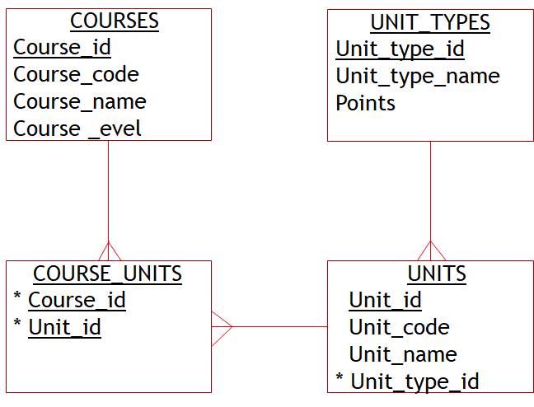

1. Creating the tables

Make sure FOREIGN KEY constraints are enabled in SQLite by entering the following command:

PRAGMA foreign_keys = ON;

The tables have to be created in the right order. Firstly the tables that don’t reference other tables i.e. don’t have any foreign keys – Courses and Unit_types. Then you can create the Units table next and finally the Course_units table.

CREATE TABLE unit_types

(unit_type_id INTEGER PRIMARY KEY AUTOINCREMENT,

unit_type_name TEXT UNIQUE NOT NULL,

points INTEGER

);

CREATE TABLE units

(unit_id INTEGER PRIMARY KEY AUTOINCREMENT,

unit_code TEXT UNIQUE NOT NULL,

unit_name TEXT NOT NULL,

unit_type_id INTEGER NOT NULL,

CONSTRAINT unit_type_fk FOREIGN KEY (unit_type_id)

REFERENCES unit_types(unit_type_id)

);

CREATE TABLE courses

(course_id INTEGER PRIMARY KEY AUTOINCREMENT,

course_code TEXT UNIQUE NOT NULL,

course_name TEXT NOT NULL,

course_level TEXT CHECK (course_level IN ('MSc','BSc','HND'))

);

CREATE TABLE course_units

(course_id INTEGER,

unit_id INTEGER,

CONSTRAINT course_unit_pk PRIMARY KEY (course_id, unit_id),

CONSTRAINT course_code_fk FOREIGN KEY (course_id)

REFERENCES coursed(course_id),

CONSTRAINT unit_code_fk FOREIGN KEY (unit_id)

REFERENCES units(unit_id)

);

1. Altering the design

After coming up with the design, we have found that we have missed out an attribute from the COURSES table to store the length of the course.

Use the following command to ALTER the table to add this column:

ALTER TABLE courses

ADD COLUMN course_length INTEGER;

We then discover that there should have been a CHECK constraint on the course_length column to only allow values between 1 and 4 but as the SQLite ALTER TABLE command does not provide a way to add a constraint, we will have to drop the table and recreate it correctly as follows:

DROP TABLE course_units; -- This is required as we cant drop the course table until all

-- tables that reference it are dropped.

DROP TABLE courses;

CREATE TABLE courses

(course_id INTEGER PRIMARY KEY AUTOINCREMENT,

course_code TEXT UNIQUE NOT NULL,

course_name TEXT NOT NULL,

course_level TEXT CHECK (course_level IN ('MSc','BSc','HND')),

course_length INTEGER CHECK (course_length between 1 and 4)

);

CREATE TABLE course_units

(course_id INTEGER,

unit_id INTEGER,

CONSTRAINT course_unit_pk PRIMARY KEY (course_id, unit_id),

CONSTRAINT course_code_fk FOREIGN KEY (course_id)

REFERENCES courses(course_id),

CONSTRAINT unit_code_fk FOREIGN KEY (unit_id)

REFERENCES units(unit_id)

);

1. Inserting data

Copy and paste the following commands to populate the database:

INSERT INTO unit_types (unit_type_name, points)

VALUES ('Basic',8);

INSERT INTO unit_types (unit_type_name, points)

VALUES ('Intermediate',11);

INSERT INTO unit_types (unit_type_name, points)

VALUES ('Advanced',15);

INSERT INTO courses (course_code, course_name, course_level, course_length)

VALUES ('B74','Comp Science','BSc', 3);

INSERT INTO courses (course_code, course_name, course_level, course_length)

VALUES ('B94','Comp Applications','MSc', 2);

INSERT INTO units (unit_code, unit_name, unit_type_id)

VALUES ('B741','Program 1',1);

INSERT INTO units (unit_code, unit_name, unit_type_id)

VALUES ('B742','Hardware 1',1);

INSERT INTO units (unit_code, unit_name, unit_type_id)

VALUES ('B743','Data Processing 1',1);

INSERT INTO units (unit_code, unit_name, unit_type_id)

VALUES ('B744','Program 2',2);

INSERT INTO units (unit_code, unit_name, unit_type_id)

VALUES ('B745','Hardware 2',2);

INSERT INTO units (unit_code, unit_name, unit_type_id)

VALUES ('B951','Information',3);

INSERT INTO units (unit_code, unit_name, unit_type_id)

VALUES ('B952','Microprocessors',3);

INSERT INTO course_units (course_id, unit_id)

VALUES (1,1); -- 'B74','B741'

INSERT INTO course_units (course_id, unit_id)

VALUES (1,2); -- 'B74','B742'

INSERT INTO course_units (course_id, unit_id)

VALUES (1,3); -- 'B74','B743'

INSERT INTO course_units (course_id, unit_id)

VALUES (1,4); -- 'B74','B744'

INSERT INTO course_units (course_id, unit_id)

VALUES (1,5); -- 'B74','B745'

INSERT INTO course_units (course_id, unit_id)

VALUES (2,6); -- 'B94','B951'

INSERT INTO course_units (course_id, unit_id)

VALUES (2,7); -- 'B94','B952'

INSERT INTO course_units (course_id, unit_id)

VALUES (2,1); -- 'B94','B741'

Select from each of the four tables to check that the data has inserted correctly. Notice we did not insert data into the primary key columns but these were automatically populated by a SQLite sequence created by the AUTOINCREMENT clause on the CREATE TABLE commands.

1. Updating and deleting data

Update the Unit table and change the name of unit B741 to ‘Programming 1’

UPDATE units

SET unit_name = 'Programming 1'

WHERE unit_code = 'B741';

Update the Unit table and change the name of unit B744 to ‘Programming 2’

UPDATE units

SET unit_name = 'Programming 2'

WHERE unit_code = 'B744';

Update the Course table and do a global replace of ‘Comp’ with ‘Computing’ in the course name column.

UPDATE courses

SET course_name = 'Computing '||SUBSTR(course_name,6,LENGTH(course_name)-5)

WHERE course_name like 'Comp %';

The ‘Hardware 2’ unit is no longer being run so remove it from all courses that teach it and then remove the unit itself. Assume you don’t know the unit code.

DELETE FROM course_units

WHERE unit_id = (SELECT unit_id

FROM units

WHERE unit_name = 'Hardware 2');

DELETE FROM units

WHERE unit_name = 'Hardware 2';

1. Testing the constraints
2. NOT NULL constraint

INSERT INTO courses (course_code, course_level)

VALUES ('B84','BSc');

Should generate a NULL constraint failed: course.course_name error as a NULL value is not allowed in the course_name column.

1. UNIQUE constraint

INSERT INTO units (unit_code,unit_name, unit_type_id)

VALUES ('B951', 'Data Analysis', 2);

Should generate a UNIQUE constraint failed: units.unit_code error as unit code B951 already exists

1. FOREIGN KEY constraint

INSERT INTO course_units

VALUES (3,1);

Should generate a FOREIGN KEY constraint failed error as the course_id 3 doesn’t exist in the Courses table.

DELETE FROM units

WHERE unit_code = 'B741';

Should generate a FOREIGN KEY constraint failed error as the unit_id of 1 which relates to unit_code B741 exists in the Course_units table.

1. CHECK constraint

UPDATE courses

SET course_length = 5

WHERE course_code = 'B74';

Should generate a CHECK constraint failed error as the course_length must be between 1 and 4.